TNC/SMA-JK
TNC Plug to SMA Jack
KNT item type: TNC/SMA-JK
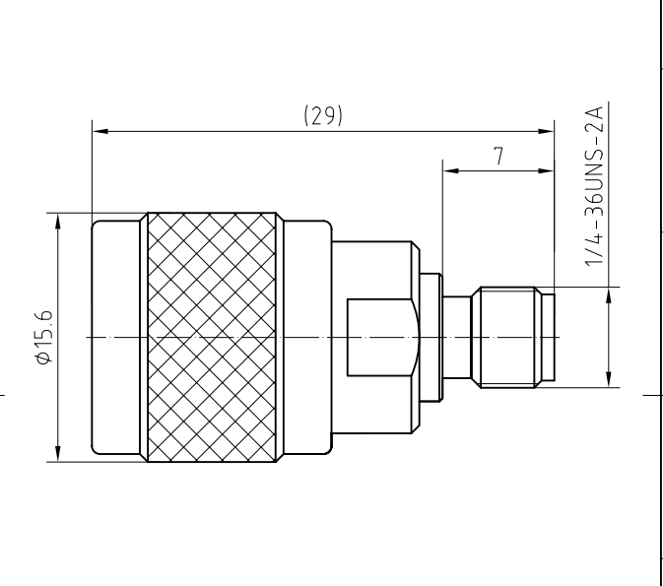

Electrical data:
Impedance: 50 ohm
Frequency range: DC to 10GHz
Return loss: > 33dB DC to 1GHz
> 30dB 1 to 2GHz
> 28dB 2 to 4GHz
Insertion loss: <0.35dB DC ~ 4GHz
Insulation resistance: >5000 ohm
Test Voltage: 1000 V rms
Working Voltage: 480 V rms
Contact resistance:
1). Centre contact: < 1.5M ohm TNC side; <3m ohm SMA side
2). Outer conductor: <1m ohm TNC side; < 2m ohm SMA side

